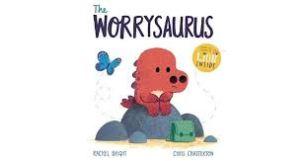

Listen to the story by following the link - https://www.youtube.com/watch?v=GYV_o9Uj2jc The Worrysaurus – read by the author, Rachel Bright
How do you feel when you get worried - like you might cry? That you want to be on your own and not to talk to anyone? That you need a hug? Or does it make you grumpy and cross with other people? Does your tummy feel like it has butterflies like the Worrysaurus?
What things would you put in your tin to make you feel better?
Have you got a better way to get rid of your worries? Remember that sharing your worries with someone else often helps them to go away.

