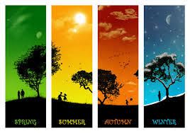
Science - Seasons and Change
https://classroom.thenational.academy/lessons/how-does-the-weather-change-across-the-seasons
Complete the 2nd lesson on Oak Academy - Year 1 - Foundation - Science - Seasons and Change - Lesson 2 How does the weather change across the seasons? You can follow the link above for this. You will need a pencil and some paper.
Try to keep your weather log for a whole week.
If you can't access the lesson Look outside your window, what is the weather like today? Write the day of the week at the top of a piece of paper and write some words to describe today's weather. Keep doing this every day for a week. Compare the weather each day.

