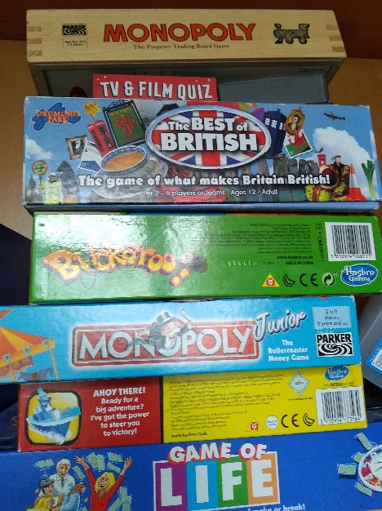

Games
Play a game with at least one other person. It can be a board game, an outdoor game, a guessing game, anything you like to do. Tell me what game you chose and who you played it with. If you want to you can tell me how you played it and what you needed to play.

