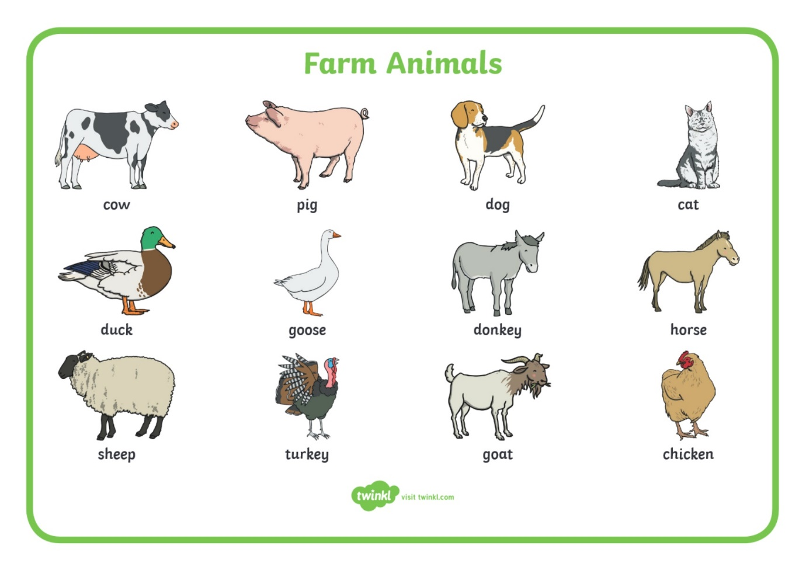

Monday
Animal Guess Who.
Play "I'm thinking of an animal" with a grown up. Take turns to describe an animal and to guess.

Tuesday
Giving the animals names
The farmer needs to name all his animals. Can you think of a name for each one that begins with the same letter sound as the animal, for example Daisy dog?

