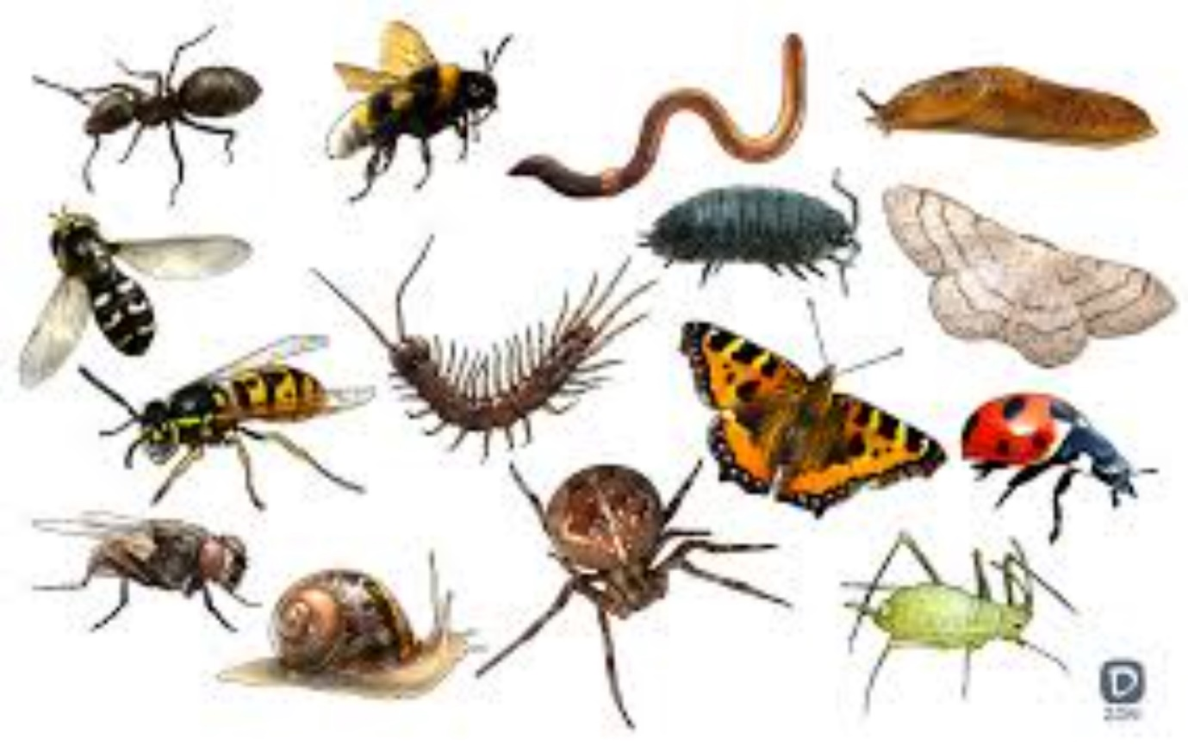

Alphabet minibeasts
How many minibeasts can you think of beginning with different letters of the alphabet? I have given you a few picture clues to start you off.

