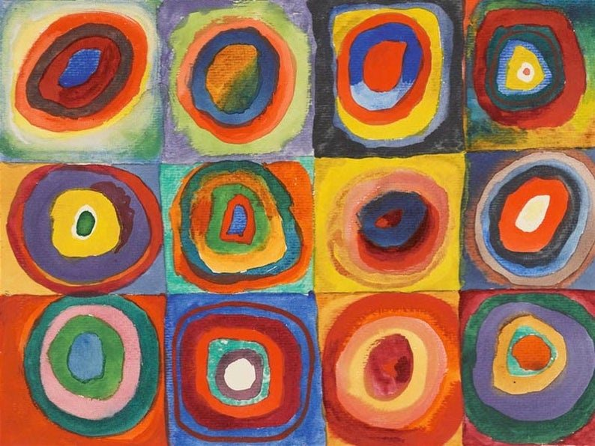

Circles
Take a look at the painting. What shapes can you see?
Can you find some circles around your house or garden?
Can you use some of the circles to draw around and colour, or paint, to make your own picture?

