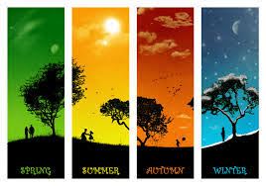
Look outside your window. What is the weather like today?
Draw a picture showing today’s weather and label the weather features.
Write a sentence about today’s weather using some weather vocabulary e.g.
Today the weather is cloudy and it looks like it might rain soon.

Talk about the 4 seasons – can you name them?
What season are we in now? Talk about the different weather we get in each season.

