Look around your house for clocks and other things that show the time.
Fill in the tally chart to see how many you can find. Which do you have more of?
Time tally chart
Analogue clocks
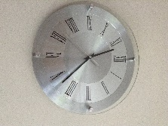

Digital clocks
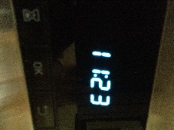

Challenge - look carefully at the numbers on digital clocks, they are made from small lines. Write your own digital numbers from 0 to 9 or make them from something like cocktail sticks or art matchsticks.
