Tuesday
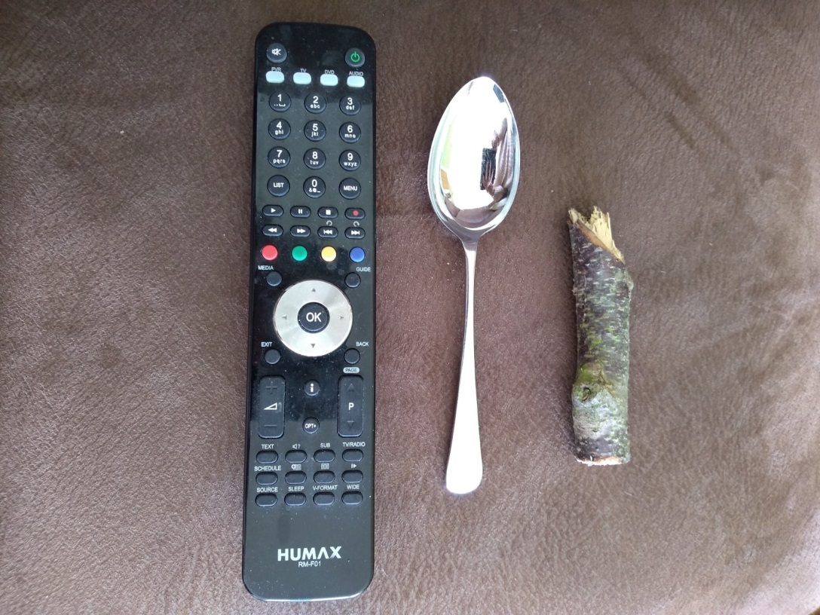

Measuring.
Get a spoon. Find 3 things that are longer than your spoon and 3 things that are shorter than your spoon.

