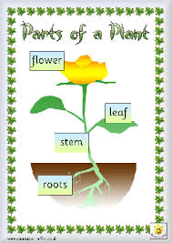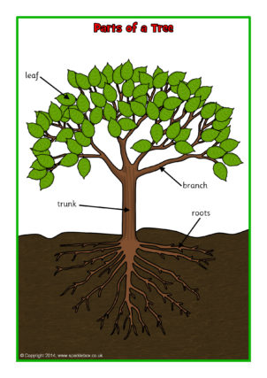

Watch the video - BBC Bitesize KS1 Science Plants - What are the parts of a plant?
Find a plant or a tree in your garden or when you are out on a walk and see if you can name the different parts.
Back at home draw, paint or make your own flower or tree (use cardboard tubes, paper, tissue etc if you have them).
Write labels for the different parts of your plant.

