Monday
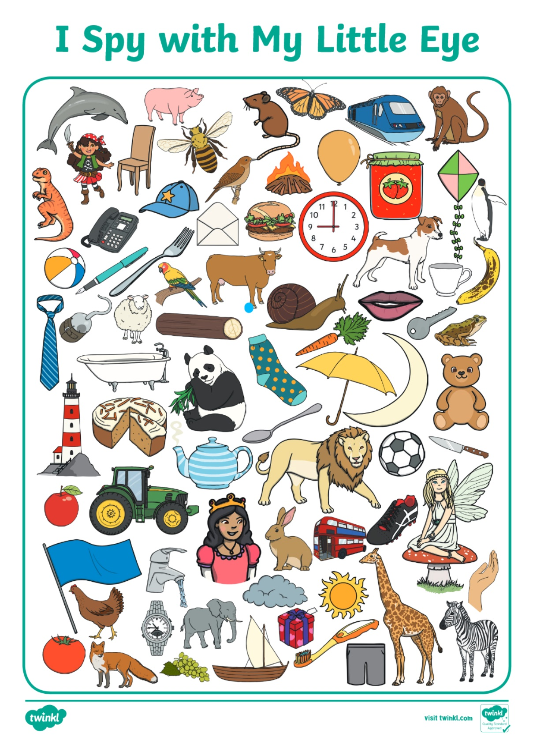

I Spy
Play I Spy with a grown up or older brother or sister. Play inside or outside looking at the things around you or you can use the picture sheet attached to choose your items.

