Now the weather is getting warmer we need to think about staying safe in the sun.
Ask a grown up to help you find this clip on Youtube

https://www.youtube.com/watch?v=vxAsoBXmCJk

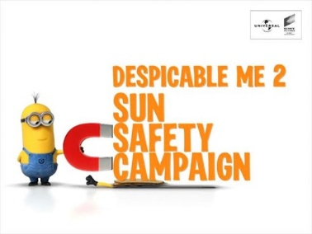
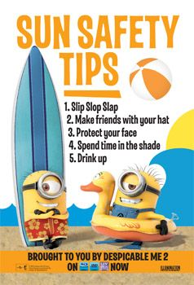
What were the 5 top tips to stay safe in the sun?

Choose one of those 5 and make a poster to help teach other people what they should do in the sun. Remember to draw a minion and write your safety message in big colourful letters. It needs to be bright and colourful so that people look at it.

