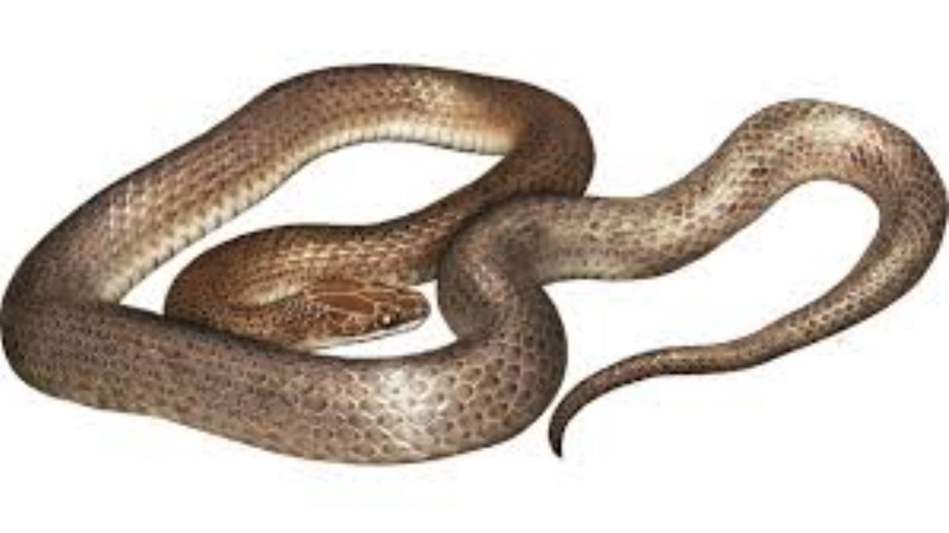
Things beginning with "s"
Listen for the sound at the beginning of the word 'snake'.
Snake begins with a 's'. What other things begin with 's' ?
Can you find something in your house that begins with 's'?

